- Array
- 
- 

Metapopulation: Internal Colonization - EcoVirtual
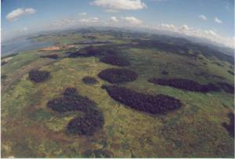Ilhas dos Barbados - Reserva Biológica Poço das Antas. Foto: Ernesto Viveiros de Castro. http://www.biologia.ufrj.br/labs/lecp/linhas.htm
There's an assumption in the last model (Metapopulations and propagule rain - Tutorial in EcoVirtual) that we can get rid off: the assumption that the propagule rain is constant. Instead, we can make the colonization rate a function of the percentage of occupied patches. In a simple formulation of this model, the propagule source is just from within the system (closed system) and the probability of colonization increases linearly with the proportion of occupied patches.

The model
This way, our model does not have a constant colonization rate , but a probability of colonization that depends on the number of occupied patches:
here is a constant that indicates how much the colonization probability increases with every new occupied patch. This way, the more occupied patches we have, the greater is the probability that new patches will be occupied. Substituting this new formula for in our old equation, we have:

Equilibrium
The fraction of the occupied patches in equilibrium(F) changes to:

Simulação
Let's see this first-hand by simulating this situation. As in the last exercise, we have created an R function that runs the simulation for us. As before, this function simply draws random colonization and extinction events for every patch at every time step, following the model's rules. It then shows the graph and an occupancy matrix for every time interval.
To proceed, you must have the R environment with the Rcmdr and Ecovirtual packages installed and loaded. If you do not have and do not know how to have them, see the Installation page.
To run this model in EcoVirtual use the function Internal colonization do sub-menu Metapopulation in the Rcomander/EcoVirtual menu.
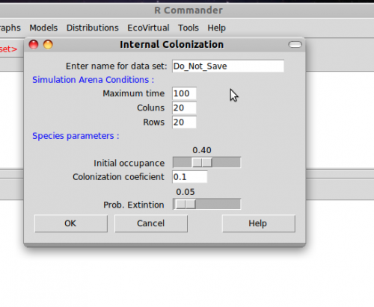
The parameters are:
option | parameter | definition
data set | R object | where the results are stored
Maximum time |  | Number of model iterations
columns |  | number of habitat columns in the landscape
rows |  | number of habitat rows in the landscape
initial occupance |  | initial number of occupied patches
colonization coef. |  | colonization coefficient
prob. extinction |  | extinction probability
Now you can simulate the model with the values you chose. For example,
tmax = 100
ncol = 10
nrow = 10
f0 = 0.1
ci = 1
pe = 0.5
Play around with the model for a while by changing the parameters and try to answer the following questions:
- is there any difference between this model and the seed rain, keeping the shared parameters equal?
- does the position of a patch in the landscape affect its or ? Is this realistic?
- are there any combinations of and that cannot exist?
- what is the meaning of a negative F?
- in which situation the equilibrium is

Scenario suggestion
tmax = 100
cl = 10
rw = 10
f0 = 0.1
ci = 0.5
pe = 0.5

To learn more
- Gotelli, N. 2007. Ecologia. Londrina, Ed. Planta. Capítulo 4.
- Stevens, M. H. 2009. A primer of ecology with R. New York. Springer.Capítulo 4.
- Gotelli, N. 1991. Metapopulation models: the rescue effect, the propagule rain, and the core-satellite hypothesis. The American Naturalist, 138: 768-776. pdf no site do autor
tag>RCMDR uma_população metapopulações colonização_interna

