- Array
- 

Stability in Dynamical Systems - Interactive Tutorial

Equilibrium and stability are very important concepts in ecology, but they have many conflicting definitions. One of the most used was brought from the branch of physics and mathematics called dynamical systems analysis.
It is this approach that brought to ecology equations to describe the dynamics of populations, such as logistic growth equation and the system of Lotka-Volterra equations.
There are techniques designed to evaluate whether these systems of equations have equilibrium points, and, if so, whether these equilibriums are stable. This exercise is an informal demonstration of stability analysis of an equation that represents a dynamic system. The objective is to make you understand the concepts of equilibrium and stability used in dynamic systems, to differentiate it fro other definitions of equilibrium and stability in ecology.

The logistical model
Let's start with the stability analysis from the well-known logistic population growth equation:
Here is the population growth speed1), is the intrinsic population growth rate, and is the carrying capacity.
Click in the button `Evaluate` below to open a interactive graph of the logistical model. Try to change the parameters of the model and see how each parameter affects the dynamic.

Logistic Equilibrium
The basic question for stability analysis in dynamical systems is: where are the system's stable equilibrium points? To answer that, we first need to say what we mean by equilibrium:
The equilibrium population size is one in which the growth speed is zero, ie, in which:
There are two population sizes that satisfy this condition for the logistic equation:
The fact that these are equilibrium points has a lot of biological meaning: the population cannot grow when it arrives at the carrying capacity, nor when it's empty.
Make sure that these are really equilibrium points with the interactive graph above. To do that, just turn the inicial population size (N0) equals to equilibrium size.

Logistic stability
Are these equilibrium points stable? Let's define more precisely what we mean by that:
One equilibrium point is locally stable if the system returns to it after a small perturbation. A small perturbation might be a small increase or decrease in the population size. Click in the button `Evaluate` below to plot the logistic equation with two arguments to include perturbation:
- Disturb : amount of perturbation
- Disturb time : perturbation time
Use these arguments to add one individual2) to the populations starting with population sizes zero and .

Questions
- Are this points stable?
- What is the biological interpretation for this?

Mathematical interpretation
The stability criterion we use evaluates the behavior of the growth rate, when the population size varies slightly around the equilibrium point. What is the relationship between growth rate and population size in the logistic equation?
See the figure below: the speed has a quadratic relationship with the population size, forming a parabola. The equilibrium points, wherein the growth velocity is zero, are marked in red 3).
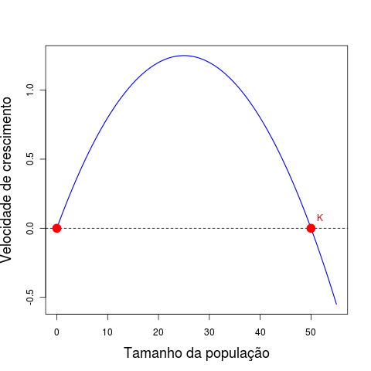 Growth speed V or dN/dt, as a function of population size, for a logistic growth. Parameters: r=0,1 , K=50
When the population is small, the population growth makes the growth rate increase, ie, more population size accelerates its growth.
From a certain population size, called inflection point of the curve, the increase in the population causes a decreasing speed. From this point on population size “brakes”4) growth.
This is the very expression of the logistic equation: growth close to exponential when the population is small, and reducing speed up to a full stop, when the population reaches the carrying capacity. Therefore, the speed has a positive relationship with population size close to equilibrium . Therefore, a small increase above zero increases the growth rate, which increases the population size, which further increase the growth rate. This is an unstable equilibrium: a small perturbation will make the population size move away from it.
At the point , the opposite happens: the rate has a negative relationship with population size. If we reduce the population slightly below , it will grow, but this growth will reduce the growth rate until the rate is zero. If we increase the population slightly above the carrying capacity, the speed is negative 5), and the population will reduce back to , as the negative speed also slows down. Thus, disturbances in the neighborhood of the carrying capacity are attracted back to this point.
In summary, what defines the stability around an equilibrium point is the sign of the relationship between the growth rate and population size in this neighborhood. This corresponds to the sign of the slope of a line tangent to the equilibrium point, which is the derivative of velocity with respect to population size at these points.
Below is the same parable of the previous figure, now with tangent lines added to the equilibrium points, with the parameter “Evaluation point”. Verify if the slope of the line is positive in and negative in .
With this, we arrive at a criterion of local stability for one population with continuous growth:
A population size in equilibrium is locally stable if the derivative of the growth rate relative to population size at this point is negative. In mathematical terms, this is:
We can read this as: “The derivative of in respect to at the point is negative”.

CODA
Why so many bold words? To remember that all this reasoning is valid only in the neighborhood of a point.
The derivative can be seen as a straight line approximating a function at one point. In the neighborhood of this point this linear approach works well, and we can focus on evaluating the behavior of the tangent line slope (ie, the sign of the derivative at point) in order to represent small changes to the function.
So the full name of what is presented in this tutorial should be local stability analysis by linear approximation.
It evaluates the response of systems of differential equations after small disturbances in the neighborhood of their equilibrium points. This is done under the premise that in this neighborhood the speed functions are well approximated by its derivatives.
This analysis does not provide any guarantee on the outcome of major disruption, and may also fail to systems with strongly nonlinear behavior.

To learn more
- Gotelli, N. 2007. Ecologia. Londrina, Ed. Planta. (A basic reference about the dynamic models in ecology).
- May, R.M. 1972. Will a large complex system be stable? Nature, 238, 413-414. (The classic paper that established the concept of trophic network stability as a solution for a Lotka-Volterra system.)
- May, R.M. 2001. Stability and complexity in model ecosystems. Princeton, Princeton University Press. (In this influent monograph, Robert May develops the ideas of the 1972 paper. The first edition is from 1973, but it was republished by Princeton Landmarks of Biology in 2001.)
- Sarah P. Otto & Troy Day 2007. A Biologist's Guide to Mathematical Modeling in Ecology and Evolution. Princeton, Princeton University Press. (A great introduction to the maths behind these models, from biologists to biologists, using more intuitive approaches to the problems. A great source if you want to understand the details of the analyses used in this tutorial. See also the book site.)
- Our tutorial on Stability and diversity, in which the analysis done here is generalized for a system with more than one species.
- R Development Core Team (2012). R: A language and environment for statistical computing. R Foundation for Statistical Computing, Vienna, Austria. ISBN 3-900051-07-0, URL http://www.R-project.org/.
tag> R cálculo derivada equação_diferencial lotka-volterra crescimento_logístico

1)which can also be written dN/dt
2)rigorously, this perturbation can be considered “large”, but it will work for our examples
3)They are the roots of the quadratic equation.
4)in physics terminology, this is negative acceleration
5)make sure you saw this in the figure!

